PHARMACEUTICAL INDUSTRY REPORT.

**INDUSTRY ANALYSIS**

**Report Made by – Syed Kawish Ahmad**

### 

**Disclaimer**

This report is not for investment advice. We are not legally responsible for the investment decisions you make based on this report.

**CONTENTS**

* Introduction
* Global Pharmaceutical Market.
* Overview of Indian Pharmaceutical Market.

1. *Overview of the Indian Pharmaceutical industry.*
2. *Domestic Pharmaceutical Demand.*
3. *Industry dynamics Pricing Pharmaceutical.*
4. *Imports and Exports Tax, duties and cess.*

* Procurement of Raw Material
* Market Structure of Pharmaceutical Industry.
* Growth prospects of Indian Pharmaceutical Industry
* Government Initiatives.
* Environmental Impact and Social Impact.

**CONTENTS IN BRIEF :**

1. Introduction …………………………………………………………. 6
2. Overview of Global Pharmaceutical Industry……………………. 7
3. Top 10 Pharmaceutical Producing Countries in the World …... 8
4. Overview of Indian Pharmaceutical market …………………… 10

* Domestic Pharmaceutical Demand………………………... 12
* Industry Dynamics -Demand & Availability ………………12
* Pricing of Pharmaceutical Products …………………….….12
* Imports………………………………………………………….13
* Exports………………………………………………………….14
* Tax Duties & Cess……………………………………………..15

1. Procurement of Raw material ………………………………………15
2. Market Structure of Indian Pharmaceutical Industry…………....16
3. Growth Prospects of Indian Pharmaceutical Industry…………..17
4. Government Initiatives………………………………………………18
5. Environmental Impact & Social impact……………………………19

**INTRODUCTION**

**Why is Pharmaceutical Important?**

Pharmaceuticals enhance our quality of life; consequently, their consumption is growing as a result of the need to treat ageing-related and chronic diseases and changes in the clinical practice. The market revenues also show an historic growth worldwide motivated by the increase on the drug demand. However, this positivism on the market is fogged because the discharge of pharmaceuticals and their metabolites into the environment, including water, also increases due to their inappropriate management, treatment and disposal; now, worldwide, this fact is recognized as an environmental concern and human health risk. Pharmaceuticals have been used to treat illnesses for thousands of years. The early days of medication included plants and herbal remedies to treat a variety of diseases and traumas. Today, the long and complex journey to demonstrate the safety and efficacy of a compound and bring it from the laboratory into the hands of patients in need, is a multi-billion-dollar global industry.

**What is Pharmaceutical made up of?**

In Pharmaceutical, Medicinal substances are added to water, alcohol, or another solvent so that they can be used in solution form. These may include spirits, elixirs, and tinctures. Ointments are one of many semisolid preparations, which also include creams, pastes, and jellies. Solid pharmaceuticals include pills, tablets, lozenges, and suppositories. In this form the compounds are more stable, with less risk of chemical reaction, and the dosage is easier to determine.

**Where is Pharmaceutical used?**

Pharmaceutical is used everywhere in the world because of the diseases and injury. This industry is being used since 1668.

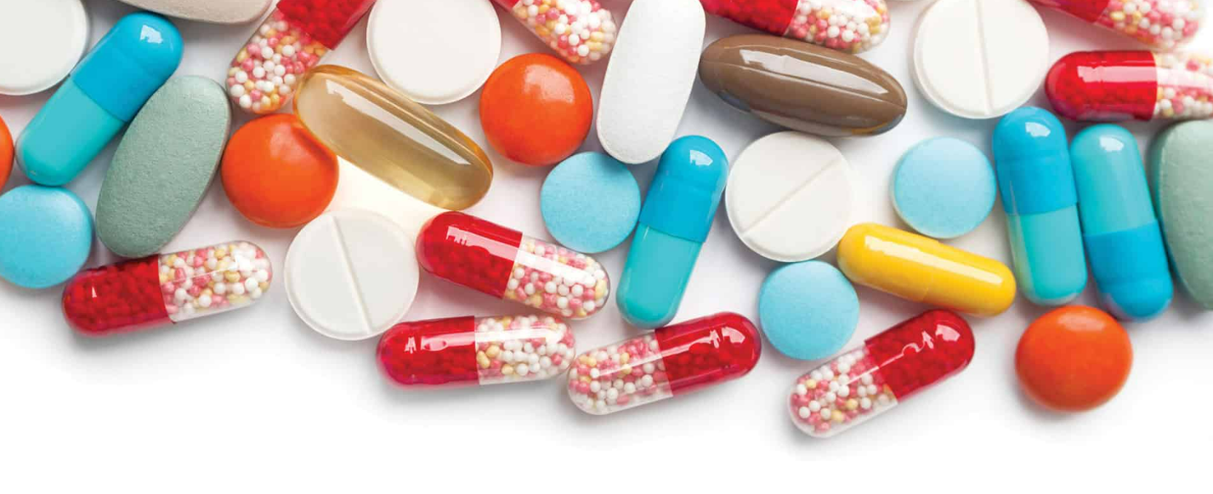

**Overview of Global Pharmaceutical Industry**

In the 1980s, when a person referred to the ‘worldwide’ pharmaceutical market, they meant only the United States, Japan, and Europe. That is because these three regions accounted for the majority of sales, solidifying their status as regulated markets. Other areas came under the umbrella of ‘developing’ markets.However, lately, there has been a significant shift in these concepts. ‘Developing’ markets rapidly turned into ‘emerging’ markets and are making their way towards acknowledgement as ‘growth’ markets.Today, China and India have become major markets with top spots in the global pharmaceutical market, with other emerging markets in Latin America, parts of Africa, and more.Together, this creates a massive potential market for the pharma industry and provides a path towards medicine becoming more accessible.

**Global Market Size:** The global pharmaceutical manufacturing market size was valued at USD 405.52 billion in 2020 and is expected to grow at a compound annual growth rate (CAGR) of 11.34% from 2021 to 2028. The pharmaceutical landscape has undergone a massive transformation with the emergence of new technologies, cost-effective, and more efficient manufacturing approaches. In addition, increasing investment flow in this space has impacted the market growth positively. Manufacturing floor downtime and the production of product waste are reduced by the implementation of robotic technology and [Artificial Intelligence](https://www.grandviewresearch.com/industry-analysis/artificial-intelligence-ai-market) (AI). In addition, single-use disposable solutions have gained momentum in this industry and have replaced conventional open transfer manufacturing techniques. Furthermore, the paradigm shift towards integrated, smart, and data-rich paperless operations has resulted in error-free and precise production. Such ongoing developments have propelled drug manufacturing.

**Employment Generation:**

The Pharmaceutical industry strongly contributes to employment in both developing and developed countries. In 2017, it employed approximately 5.5 million people worldwide, including through the manufacturing of generics medicines.233 Industry provides jobs through direct employment and induces the creation of many more indirect jobs in every country it operates.

**Global pharmaceutical growth over the last 10 years:**

This statistic displays the production value contributed by the pharmaceutical industry worldwide from 2006 to 2018. In 2018, the production value of the industry totaled approximately 1.2 billion U.S. dollars.

|  |  |
| --- | --- |
| Year | Value (Bn.USD) |
| 2006 | 651.4 |
| 2007 | 728.8 |
| 2008 | 822.8 |
| 2009 | 844.4 |
| 2010 | 870.1 |
| 2011 | 912.1 |
| 2012 | 948.7 |
| 2013 | 969.6 |
| 2014 | 996.9 |
| 2018 | 1200 |

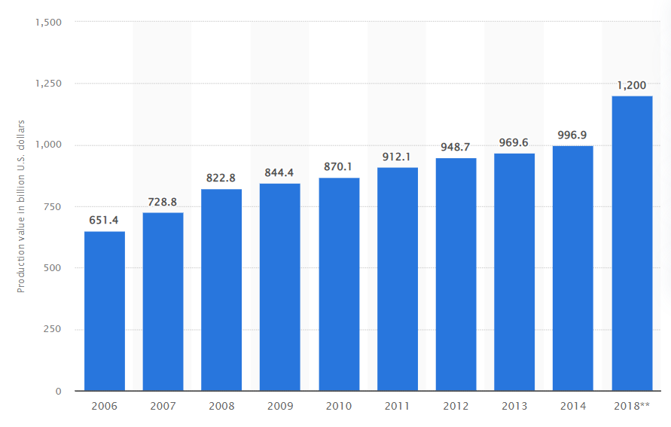

**Top 10 Pharmaceutical Production Countries in the World.**

|  |  |
| --- | --- |
| **Rank** | **Country** |
| 1 | US |
| 2 | Western Europe |
| 3 | China |
| 4 | Japan |
| 5 | Latin America |
| 6 | Russia |
| 7 | Canada |
| 8 | South Korea |
| 9 | India |
| 10 | Indonesia |

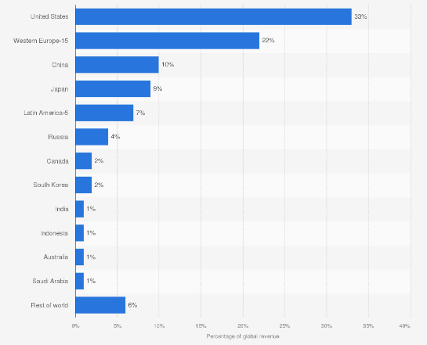

The United States being the first, followed by (the leading 15 countries from) Western Europe, had that largest share of pharmaceutical revenue globally.China be the Third followed by Japan ,Latin America ,Russia ,Canada ,South Korea ,India & Indonesia. For comparison, Australia had one of the lowest single shares among the listed countries. The data shows that the United States held 33 percent of global pharmaceutical revenue.

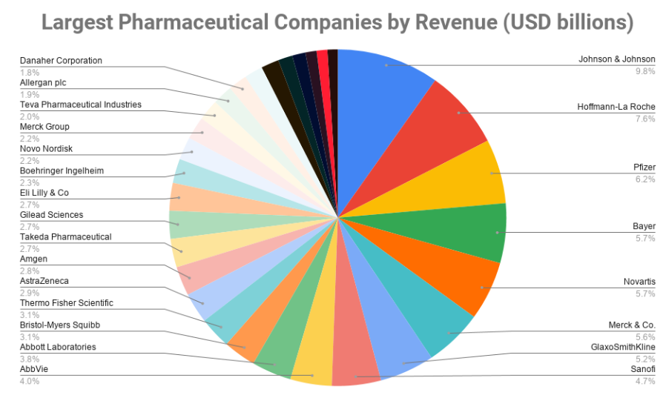

* 18 of the top 30 biggest pharmaceutical companies are US-based.
* Germany has the 2nd most companies on this list of the largest pharmaceutical companies in the world by revenue.
* All companies bring in revenues in the USD billions of figures annually.

**Overview of Indian Pharmaceutical Market**

Over the last few decades, the Indian pharmaceutical industry has experienced rapid expansion, which may be divided into four stages. We can consider the time before 1970 as the first stage of the pharma industry. At that time, the Indian market was dominated by foreign companies. The second stage covers 1970 to 1990 when several domestic companies began operations. 1990 to 2010 is the third stage, where liberalization led Indian components to launch operations in foreign countries.

**Market Size**: India is a significant player in the global medicines industry. In addition, the country holds a large number of scientists and engineers that can propel the sector forward to even greater heights.

In the manufacturing of generic medicines around the world, India takes the first place. The Indian pharmaceutical business supplies 50% of global demand for a variety of vaccines, 40% of generic demand in the United States, and 25% of all medication in the United Kingdom. As of April this year, the moving annual turnover was Rs.1.52 trillion, up from Rs.1.43 trillion in April 2020. The domestic pharmaceutical industry’s yearly revenue was Rs.1.3 trillion in April 2019.

**Contribution to GDP**: The Indian pharmaceutical sector contributes about 2 per cent to India's GDP and around 8 per cent to the country's total merchandise exports

**Employment Generation:** As per estimates the pharma industry in india currently employs about 5.5-5.7 lakh people. This increase can be attributed to the initiatives by the government.

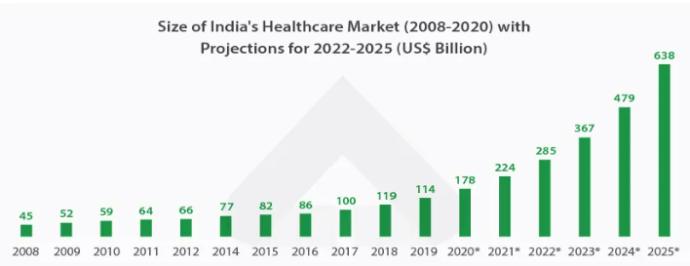

**Size of Indian pharmaceutical market & its projections.**

**Top 10 Pharmaceutical Companies in India and their Profitability.**

|  |  |  |  |  |
| --- | --- | --- | --- | --- |
| **Company Name** | **Revenue (in Rs. Cr)** | | **Profit (in Rs. Cr)** | |
|  | **FY22** | **FY21** | **FY22** | **FY21** |
| [**Sun.Pharmaceutical Industries Ltd.**](https://www.moneyworks4me.com/indianstocks/large-cap/healthcare/pharmaceuticals-drugs/sun-pharma-inds/company-info) | 38654 | 33498 | 3405 | 2284 |
| **Divis Laboratories Ltd.** | 8959 | 6969 | 2960 | 1984 |
| **Cipla Ltd.** | 21763 | 19159 | 2559 | 2401 |
| [**Dr. Reddys Laboratories Ltd.**](https://www.moneyworks4me.com/indianstocks/large-cap/healthcare/pharmaceuticals-drugs/dr-reddys-lab/company-info) | 21545 | 19047 | 2112 | 1903 |
| [**Apollo Hospitals Enterprise Ltd.**](https://www.moneyworks4me.com/indianstocks/large-cap/healthcare/hospital-healthcare-services/apollo-hospital-ent/company-info) | 10560 | 14662 | 1101 | 136 |
| **Torrent Pharmaceuticals Ltd.** | 8508 | 8004 | 777 | 1251 |
| [**Abbott India Ltd.**](https://www.moneyworks4me.com/indianstocks/large-cap/healthcare/pharmaceuticals-drugs/abbott-india/company-info) | 4919 | 4310 | 798 | 690 |
| [**Zydus Lifesciences Ltd.**](https://www.moneyworks4me.com/indianstocks/large-cap/healthcare/pharmaceuticals-drugs/zydus-lifesciences/company-info) | 15265 | 14403 | 2326 | 2205 |
| [**Max Healthcare Institute Ltd.**](https://www.moneyworks4me.com/indianstocks/large-cap/sector/hospital-healthcare-services/max-healthcare-inst/company-info) | 3931 | 2504 | 605 | -114 |
| [**Alkem Laboratories Ltd.**](https://www.moneyworks4me.com/indianstocks/large-cap/healthcare/pharmaceuticals-drugs/alkem-laboratories/company-info) | 10634 | 8865 | 1680 | 1617 |

**Pharmaceutical Exports from India.**

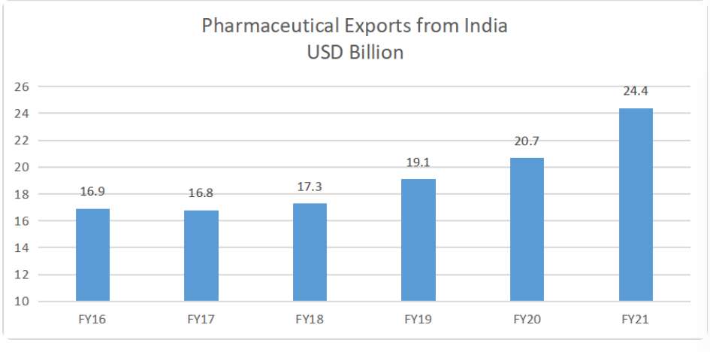

**Domestic Pharmaceutical Demand.**

Indian pharmaceuticals have time and again proved their prominence, and this time it was developing Covid-19 vaccines which globally saved millions of lives. Domestic pharmaceutical companies which were largely recognized for their affordable manufacturing of generic medicines are now being recognized for its high-quality research and development ecosystem post Covid-19, a remarkable perception shift from being a volume manufacturer to value creator. India is ranked third worldwide for production by volume, accounting for 20% of the global volume supply. ccording to IBEF, domestic pharmaceutical market stood at US$ 42 billion in 2021 and is likely to reach US$ 65 billion by 2024 and further expand to reach US$ 120-130 billion by 2030 to become the leading provider of medicines to the world.

##### **Industry dynamics – Demand and availability**

The Indian pharmaceutical industry has emerged as the third-largest country in the world in terms of volume with a turnover amounting to the US $ 21.04 billion in 2009. In addition to this, the industry includes more than 20,000 licensed companies that employ 500,000 people (Industry, 2011). Furthermore, the Indian pharmaceutical industry secured the top position among the science-based industries through a range of capabilities in production and technology. In terms of market segmentation, leading 250 pharmaceutical companies have controlled 70 % of the market (PwC, 2012).

##### **Pricing of Pharmaceutical Products.**

In India, [Pharmaceutical companies](https://vakilsearch.com/blog/pharma-drugs-and-importance-of-patents/) must obtain a patent for new drug formulations. They must adhere to the Indian [Patent Act](https://vakilsearch.com/blog/advantages-and-disadvantages-of-buying-a-franchise/) (IPA), which sets specific drug pricing requirements. The IPA stipulates that a drug must be priced no more than the cost of production plus 25% of the manufacturer’s net profit after tax. In addition, the drug must be available at a price that does not exceed the cost of production plus 50% of the manufacturer’s net profit after tax.

In India, pharmaceutical companies price drugs using a variety of methods. The most common method is to use the market price of a generic drug as a reference price. Generic drugs are often cheaper than brand-name drugs. Drug manufacturers can then set their prices based on this reference price. However, this approach has several limitations in India.

* First, the market price of a generic drug may not be available or accurate.
* Second, the market price of a generic drug may not reflect the cost of producing the drug.
* Third, the market price of a generic drug may not be fair because it does not consider how well the drug works.
* Fourth, the market price of a generic drug may not reflect how much the pharmaceutical company profits from selling the drug.
* Fifth, the market price of a generic drug may not be sustainable because it is subject to change.
* Sixth, the market price of a generic drug may be biased towards large pharmaceutical companies.

**Imports :**

* India Imports: Medicinal and Pharmaceutical Product was reported at 3,864,111.723 USD in Dec 2021.
* This records an increase from the previous number of 3,432,544.258 USD for Dec 2020.

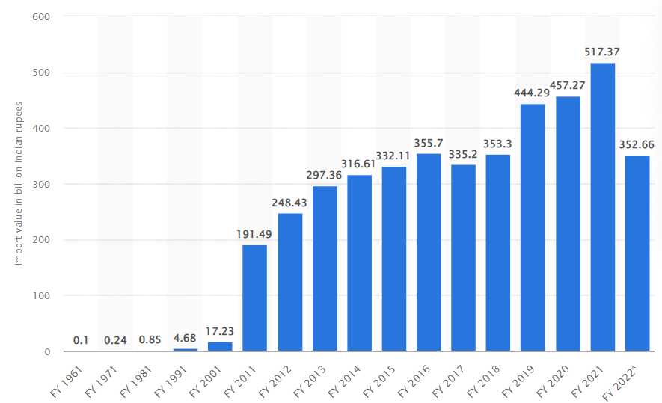

**Import Graph from India.**

**Exports :**

Pharmaceutical exports from India registered a growth of 4.22 per cent to reach USD 14.57 billion during the April-October period despite a negative trend last month, according to a senior official of an export promotion body under Government of India.

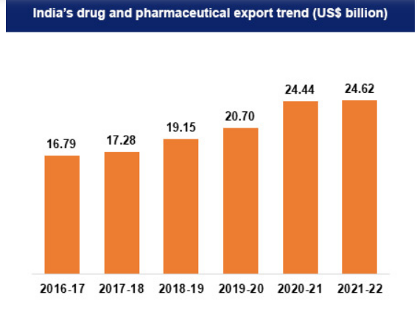

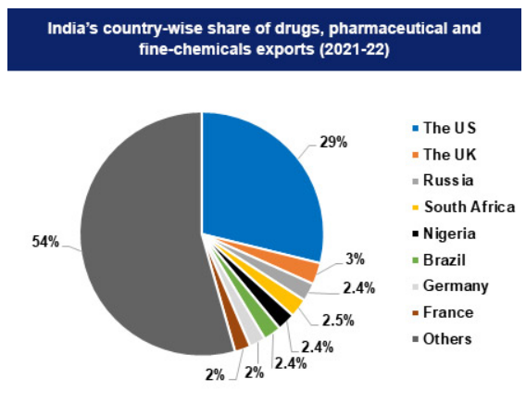

**Tax, duties and cess:**

Goods and Services Tax in India has taxed at four separate rates NIL, 5%, 12% and 18% on medicines and medical supplies. NIL rate is charged on blood and its by-products, and all contraceptives. The lowest GST rate of 5 % is charged on life-saving drugs like vaccines and medicines like those for tuberculosis, AIDS, diabetes, malaria among others. The highest GST at the rate of 18% is charged only on medicines, like nicotine gums, which contain nicotine polacrilex. Although GST is charged at the rate of 28% on some other products and services under GST but the rate is not charged on any medicines or medical supplies.

**Procurement of Raw Material :**

In order to produce quality medicines, a wide range of raw materials must be used by manufacturers. These include powders and liquids from different sources, such as plants, animals, minerals and chemical compounds. The type of material needed for a particular drug depends on its purpose. Most chemicals that form part of medications are derived from petroleum or natural gas deposits.

For example, active ingredients found in painkillers may include morphine (extracted from poppy seeds), aspirin (from white willow bark) or acetaminophen (from coal tar). By far, most active pharmaceutical ingredients (APIs) come from plant sources; around 40 percent originate from woody plants while 35 percent comes from trees and shrubs. The remaining 25 percent is derived mainly from vegetables.

There are three main types of excipients: diluents, fillers and disintegrates. The first two take up space and create bulk without adding any medicinal ingredients to a drug. It is important to note that they do not contribute to drug action. Disintegrates assist tablets or capsules in breaking down during digestion so that their active ingredients can be absorbed by your body.

Lubricants help reduce friction between tablet components as well as between them and equipment used for manufacturing. Lubricants also prevent cracking and crumbling of tablets. Guidant's increase flow properties of powders (to facilitate blending) and improve tablet uniformity by allowing particles to glide across one another more easily, thereby preventing particle aggregation/agglomeration (and subsequent lumping).

Coating agents protect drugs from degradation due to moisture loss, oxidation or other environmental factors; some act as preservatives for extended shelf life. Finally, solvents dissolve ingredients into solutions for easier processing during manufacturing. They also serve as vehicles for getting drugs into solution prior to final formulation into solid dosage forms such as pills or liquid suspensions/emulsions.

## **Market Structure of Indian Pharmaceutical Industry:**

The market structure of the pharmaceutical industry is Oligopoly. In an oligopoly market, there are only a fewer number of firms in the industry. So, each firm has the market power to estimate the market price of the product/service in the industry. The Pharmaceutical industry is considered an oligopoly market structure because of following features:

###### **Price Determination**

Price of Pharmaceutical industry is governed by NPPA. NPPA is an organization of the Government of India which was established, inter alia, to fix/ revise the prices of controlled bulk drugs and formulations and to enforce prices and availability of the medicines in the country, under the Drugs (Prices Control) Order, 1995.

###### **Supply**

**High**. In India is the world's largest provider of generic medicines by volume, with a 20% share of total global pharmaceutical exports.

###### **Demand**

India supplies over 50% of global demand for various vaccines, 40% of generic demand in the US and 25% of all medicine in the UK. Globally, India ranks 3rd in terms of pharmaceutical production by volume and 14th by value.

###### **Barriers to entry**

### **High,** due to Economies of Scale, Regulations and Approval, Investment Capital, Intellectual Property and Patents.

###### **Bargaining power of suppliers**

**Low**, Suppliers have very little power in the pharma industry. The raw materials for manufacturing drugs are usually commodity products in the chemical industry, which are available from many sources.

###### **Bargaining power of customers**

There are large number of potential customers. Bargaining power of customers is

**High**, as there are large suppliers of pharmaceutical as compared to buyers.

###### **Competition**

**High**,due Owing to the easy availability of low price as well as high quality manpower in India.

###### **Threat of Substitutes**

The threat of substitute is **low** due to no replacement of drugs which is essential for Life.

## **Growth prospects of the Indian Pharmaceutical industry**

The pharmaceuticals industry in the Indian market is expected to register a CAGR of 10.70%, over the forecast period (2022-2027).

The India Pharmaceutical Industry has emerged as greater power amid COVID-19. The growth of the India Pharmaceutical industry is largely supported by the government. The emergence of COVID-19 has led to the health crisis that the world has witnessed and had an unprecedented impact on various industries and specifically the healthcare and pharmaceuticals market. In April 2020, as the crisis deepens on a global level, the country uplifted the restrictions on the export of 24 pharmaceutical ingredients and medicines. In this current scenario with the sudden emergence of COVID-19, there is a high growing demand for vaccines as one of the most effective tools to protect against infectious diseases. For instance, in May 2021, under Atmanirbhar Bharat 3.0, Mission COVID Suraksha, the Government of India, accelerated the development and production of indigenous COVID vaccines “COVAXIN” The Department of Biotechnology, Government of India, provided financial support in the form of a grant to vaccine manufacturing facilities for enhanced production capacities, which was expected to reach 10 crore doses per month by September 2021. For these the public sector companies such as Haffkine Biopharmaceutical Corporation Ltd, Indian Immunologicals Limited (IIL), Hyderabad and Bharat Immunologicals and Biologicals Limited (BIBCOL), Bulandshahr got support from the government. Such joint efforts are augmenting the growth of the market.

The Indian pharma sector has a long history of developing and delivering world-class products at affordable costs across the globe. India has the greatest number of United States Food and Drug Administration (USFDA) approved units (741 as of August 2021). Indian pharma companies offer products in segments such as generic drugs, over-the-counter (OTC) medicines, active pharmaceutical ingredients (APIs), vaccines, contract research and manufacturing, and biosimilar and biologics. For another instance, in 2021 according to the Indian Brand Equity Foundation Report, in the case of generics, India accounts for 20% of global exports, and for the period 2021-22, the export of drugs and pharma products stood at USD 24.6 billion compared to USD 24.44 billion as of 2020-21. This constitutes about 20% of the share globally in exports of generic pharmaceutical products. To encourage investment, the approval time for new facilities has been streamlined. India plays a very crucial role in the generic aspect of the global pharmaceutical industry.

Moreover, as per the same source, the United States is India's primary export market for pharmaceuticals. For instance, in 2021 India Brand Equity Foundation reported that India ranks 3rd in volume and 14th in value concerning pharmaceutical production in the global industry and India also supplies over 50% of the global demand for vaccines, 40% of generic demand in the United States, and 25% of all the medicinal products in the United Kingdom.

Therefore, increasing the export of generic medicine and increasing research and development activities will boost the market growth in the forecast period. However, the lack of a stable pricing and policy environment and lack of development of an innovative drug may hamper the growth of the studied market.

#### **GOVERNMENT INITIATIVES**

Some of the recent government initiatives are as follows:

The Indian pharmaceutical industry is the 3rd largest in the world by volume and valued at $50 bn. The country contributes 3.5% of total drugs and medicines exported globally to over 200+ countries.

To ensure greater resilience to external shocks, enforce greater drug security and boost the capacity for domestic production for critical bulk drugs and high-value products alike, the Department of Pharmaceuticals has launched 3 supporting schemes to incentivize the global and domestic players to enhance investment and production in these product categories.

The Schemes are envisioned to ensure greater resilience of the Indian pharmaceutical industry to external shocks and contribute significantly to achieving a higher objective of affordable healthcare in the country and globally on a sustained basis.

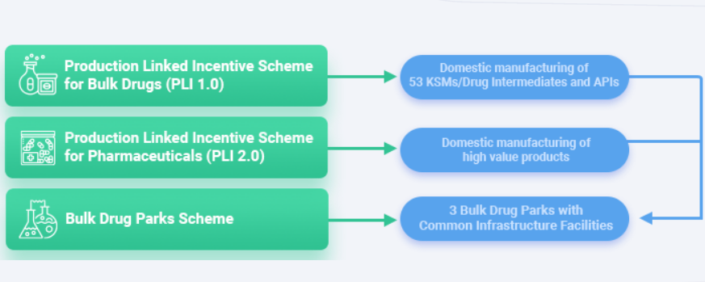

#### **Environmental Impact and Social Impact**

Pharmaceutical compounds are being used for several beneficial purposes in modern society but simultaneously pharma industries are releasing very toxic contaminants in the environment directly or after chemical modifications.Moreover, pharmaceutical compounds may enter the environment by different routes such as discharge of treated wastewater, seepage from landfills sites, sewer lines, runoff from animal wastes etc.

Even though various physical and biological processes occurring in aquatic ecosystem may cause reduction of many pharmaceutical compounds, trace concentrations of human and veterinary pharmaceutical compounds as well as their metabolites have been detected in different water bodies like surface water, groundwater and drinking water sources.

The pharmaceutical industry in India is the world's third-largest in terms of volume and stands 14th rank in terms of value. It is growing at about 8 to 9 percent annually and is estimated to be worth 4.5 billion dollar. Different industries including pharmaceuticals, chemicals, paints etc. are speedily growing in India which disposes off their effluents into the streams either directly or after partial treatment. It has been found that the pharmaceutical compounds reach the environment and can be considered as environmental pollutants.

Several pharmaceutical production facilities were found to be sources of much higher environmental concentrations than those caused by the applications of drugs.

**Environmental Impact**

**General Environmental Pollutants**

i.e. Pharmaceutical Compounds Pharmaceutical drugs being used for human as well as veterinary medicines are emerging as environmental pollutants. Different pharmaceuticals have been classified as Analgesics, Antibiotics, Antiepileptic, Antiseptics, Beta-blockers, Antihypertensive, Hormones, Contraceptives, Psychotherapeutics and Anti Virals.

**Pharmaceuticals in the Environment**

The environmental exposure routes of pharmaceuticals into the environment are manufacturing units and hospital effluents, land applications (e.g., bio solids and water reuse) etc. However; sewage treatment services are not always successful in removing the active chemicals from waste-water. Consequently, pharmaceuticals find their way into the aquatic environment, where they directly affect aquatic organisms and can be incorporated into food chains. In a recent study, the extraordinarily high levels (mg/L) of several drugs were found in the effluents from local wastewater treatment plant near Visakhapatnam in India.

**Toxicity due to Some Pharmaceutical Compounds**

Studies on antibiotics have shown that up to 95% of antibiotic compounds can be released unaltered into the sewage system. Moreover, higher concentrations of antibiotics can lead to change in microbial community structure and ultimately affect food chains. Non-steroidal anti-inflammatory drugs (NSAIDs), like ibuprofen, naproxen and diclofenac are widely being used and consequently are frequently detected in sewage, surface water and may be found in ground water system. Ibuprofen, ketoprofen, naproxen, indomethacin, diclofenac, acetyl salicylic acid and phenazone have been found in surface water system. However, diclofenac, ibuprofen and propyphenazone are the most commonly found drugs in the water bodies after clofibric acid. Moreover, diclofenac has been proven to be highly toxic for vultures and cattle’s. NSAIDs like ibuprofen, naproxen and aspirin are the most commonly used drugs, which are usually found in effective quantities in municipal effluents.

**Properties of Pharmaceutical Effluents**

Many pharmaceutical industries are responsible to generate toxic effluent as a consequence of their operation. The waste water generated from these industries possess solids, biodegradable and non degradable organic compounds etc. Pharmaceutical effluents offer basic information about the reliability of the aquatic habitat in rivers and streams, into which they are discharged. The physico-chemical analysis of the effluents should indicate that most of these industries obey the standard guidelines of Federal Environmental Protection Agency (FEPA). An important pollution index of industrial wastewaters is the oxygen content in chemical oxygen demand (COD) and biological oxygen demand (BOD), where the nutrients status are measured in terms of amount of nitrogen and phosphorus in waste water. Besides this, other significant water quality parameters include pH, temperature and total suspended solids (TSS). However; pharmaceutical effluents are also categorized by their unusual turbidity, conductivity, COD, TSS and total hardness.

**Pharmaceuticals Analysis in Drinking Water**

The mystery of pharmaceutical occurrence in drinking water has particularly concerned the public health. While unpleasant human health results from the existing levels of drugs and pharmaceuticals in drinking water are highly unlikely, the resulting impacts to aquatic ecosystems are more dangerous. Moreover, pharmaceuticals have been detected in waters for more than four decades. In the past decade, the number of papers on the analysis of drugs or pharmaceuticals in drinking water sources has increased considerably.

**Health Risk of Pharmaceutical Effluents**

The long term exposure of lower concentration of complex pharmaceutical mixtures on stream biota may result in acute and chronic damages , behavioural changes accumulation in tissues , reproductive damage and inhibition of cell proliferation. Several studies have demonstrated that fish exposed to wastewater effluents can exhibit reproductive abnormalities. Moreover, fish exposed to trace levels of birth control pharmaceuticals in the range of concentrations found in the environment show dramatic decreases in reproductive success, suggesting population level impacts are possible.

**Sustainability in pharmaceutical industry.**

Sustainability with respect to governance in the pharmaceutical industry should focus on product quality, and open association with healthcare professionals and patients. Companies need to adopt ethical standards combined with patient-oriented business model, while leveraging digital technology.

Achieving sustainability is one of the major concerns in the pharmaceutical industry

(Amran and Ooi 2014;Agaretal.2016; Sheldon 2016). Pharmaceutical manufac-

turing is complex in nature, and associated with high waste generation (Sheldon

1993) and GHG emissions. Researchers have shown greater environmental impact

of pharmaceutical per kilogram production compared to basic chemicals because

of the complex chemical formulation involved that also leads to higher waste per

kg product, and, consequently higher fossil-fuel consumption. Cumulative energy

demand is 20 times greater and GWP is 25 times higher than basic chemical product’s

production (Wernet et al. 2010; Cespi et al. 2015). Having its concerns on climate

change (http://web.unep.org/), reported that green-house gas emissions are the main

culprit and dominant factor for climate change. Thus, with a goal of exploring

sustainability awareness in Indian pharmaceutical industry this work aims to establish

its relation with environmental aspects, economic aspects, social aspects i.e. triple

bottom line (TBL) and external forces that can act as a key driver and contribute

to achieving sustainability

Achieving sustainability is one of the major concerns in the pharmaceutical industry

(Amran and Ooi 2014;Agaretal.2016; Sheldon 2016). Pharmaceutical manufac-

turing is complex in nature, and associated with high waste generation (Sheldon

1993) and GHG emissions. Researchers have shown greater environmental impact

of pharmaceutical per kilogram production compared to basic chemicals because

of the complex chemical formulation involved that also leads to higher waste per

kg product, and, consequently higher fossil-fuel consumption. Cumulative energy

demand is 20 times greater and GWP is 25 times higher than basic chemical product’s

production (Wernet et al. 2010; Cespi et al. 2015). Having its concerns on climate

change (http://web.unep.org/), reported that green-house gas emissions are the main

culprit and dominant factor for climate change. Thus, with a goal of exploring

sustainability awareness in Indian pharmaceutical industry this work aims to establish

its relation with environmental aspects, economic aspects, social aspects i.e. triple

bottom line (TBL) and external forces that can act as a key driver and contribute

to achieving sustainability

Achieving sustainability is one of the major concerns in the pharmaceutical industry

(Amran and Ooi 2014;Agaretal.2016; Sheldon 2016). Pharmaceutical manufac-

turing is complex in nature, and associated with high waste generation (Sheldon

1993) and GHG emissions. Researchers have shown greater environmental impact

of pharmaceutical per kilogram production compared to basic chemicals because

of the complex chemical formulation involved that also leads to higher waste per

kg product, and, consequently higher fossil-fuel consumption. Cumulative energy

demand is 20 times greater and GWP is 25 times higher than basic chemical product’s

production (Wernet et al. 2010; Cespi et al. 2015). Having its concerns on climate

change (http://web.unep.org/), reported that green-house gas emissions are the main

culprit and dominant factor for climate change. Thus, with a goal of exploring

sustainability awareness in Indian pharmaceutical industry this work aims to establish

its relation with environmental aspects, economic aspects, social aspects i.e. triple

bottom line (TBL) and external forces that can act as a key driver and contribute

to achieving sustainabil